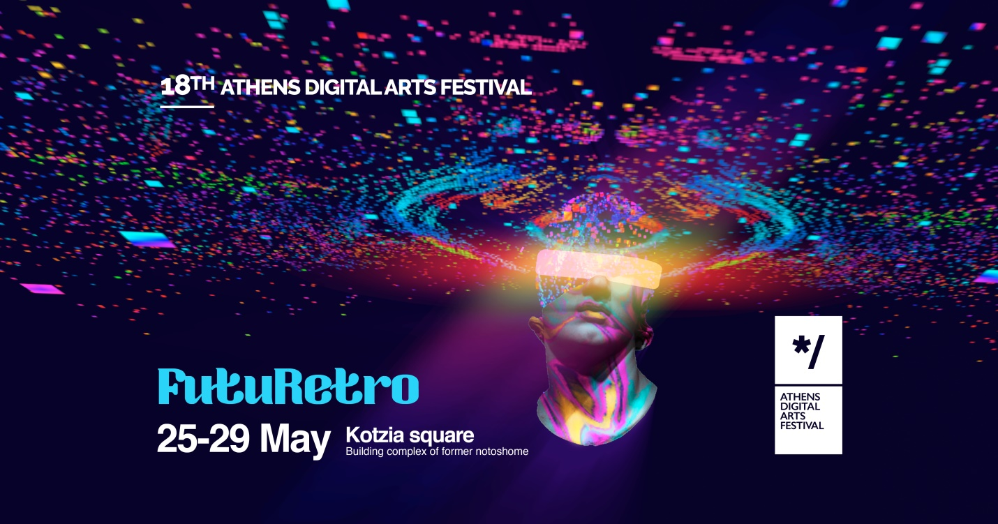
18th Athens Digital Arts Festival
“FutuRetro”
25 - 29 May 2022
Kotzia Square, Athens City Center
Βuilding complex of former notoshome

The Athens Digital Arts Festival (ADAF) presents FutuRetro, a celebratory 18th edition and a five-day gathering in the heart of Athens at the historical landmark of Kotzia Square.

From the 25th - 29th of May, the building complex of former notoshome and Kotzia Square will be revived to host an innovative exciting program with works from 12 categories: Video Art, Animation, Interactive Installations, Virtual and Augmented reality (VR/AR), Games, Digital Image, Web Art, Live Performances, Workshops, Talks and ADAF KIDS, a mini digital arts festival dedicated to children. This year ADAF is especially excited to present a curated program for the ADAF MUSIC category.

The theme, FutuRetro, focuses on science fiction, retrofuturism and futurology and aims to present the technological milestones of today through the eyes of the past and as a foreshadowing means for the future. Marking its third year as a Hybrid Festival, the online edition of the festival, ADAF ONLINE, will be launched in the fall of 2022 as an extension to the physical edition and in an effort to make the festival and its works accessible to a truly limitless, global audience.

With the selection process in its final stage, ADAF’s international open call has yet again received an overwhelming number of submissions, 5,700 works from artists, scientists, intellectuals, and technologists from around the world. Parallel to the open call, the Festival continues to expand its network by cultivating bridges with local and international festivals, universities and institutions to exchange knowledge, art and to showcase global trends in digital arts.

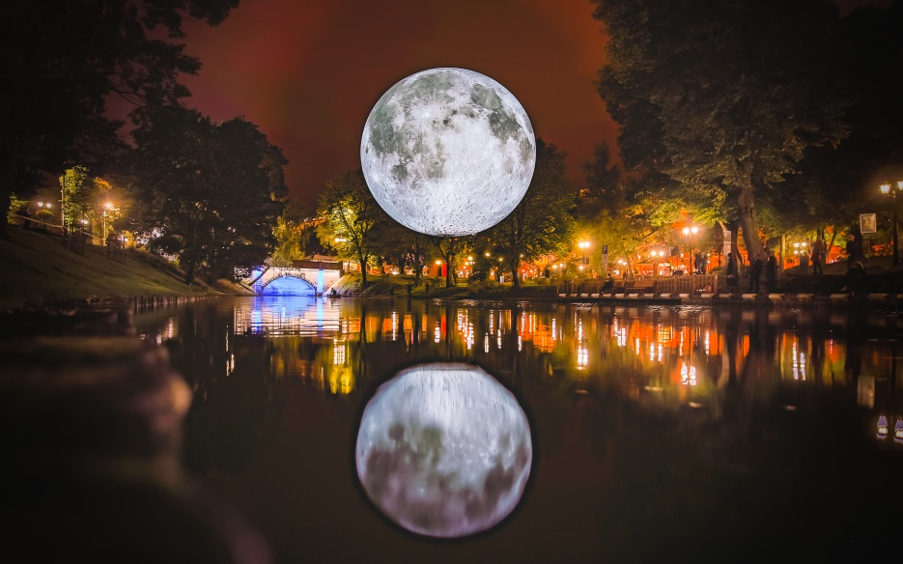
Museum of the Moon - Luke Jerram

Do not miss!
- 3D Projection Mapping Show on Athens City Hall.
- The Museum of the Moon installation lands in Athens! With a diameter of 7 meters, the artwork consists of 120 dpi photographs of the moon's surface as taken by NASA. A work by British artist Luke Jerram, presented for the first time in Greece.
- All-day Cinemateque with video art & animation screenings, Festivals of the World, and special screenings (10.00 - 23.00).
- SUPERSELFIE, an interactive installation by Chilean Felipe Prado, exploring how we create for a minute "an offline social network", in which we can be close to each other in physical presence.
- Music Doubles as part of ADAF Music programme, the daily music performances on the ADAF Stage at Kotzia Square (20.00 - 23.00), including Lena Platonos, Marina Satti, Kaiti Garbi, Nikos Touliatos, Stelios Giannoulakis Someone who isn't me, Die Arkitekt , Katia Paschou, Vagelis Serifis - ΝΕΒΜΑ, Konstantine Pope & Jeph Vanger and many more artists. Music Doubles brings to the stage unexpected and unique collaborations between musicians from different music genres and eras, creating a multi-dimensional blend of Greece's contemporary musical references.
- The performance Unsculpt by Myriam Bleau (CA) on the ADAF Stage.
- Flooor, an installation - game with light for the ADAF KIDS category by Håkan Lidbo (SE).
- Robotize it! A showcase event of DIY Robots.
- The NFT workshops. Learn everything about NFT artworks by the experts.

A few words about the location

The Athens Digital Arts Festival traditionally takes place during spring in the Historic Center of Athens, each time activating and reinventing city landmarks and spaces, engaging the local community and creating new paths where one can explore and experience the city in a new and unique way. This year, ADAF selects the city landmark of Kotzia Square and the former notoshome building complex to host its exciting program.
The main exhibition will be open to public from 10:00 to 23:00 and it will take place in an impressive building complex, of over 12,000 m² on Kotzia Square, where notoshome department store was housed from 2003 until its relocation in 2018 in the notos beauty & fashion department store (6th & 7th floor, Stadiou & Aiolou Str). To celebrate the 18th Athens Digital Arts Festival and as an invitation to its customers and pedestrians, the notos department store will feature an impressive interactive installation in one of its windows.
In the meantime, we invite you to visit our last edition Tāctus, with an exciting 3D Virtual Tour to see the artworks showcased at the 17th Athens Digital Arts Festival which took place at the Museum of Modern Culture.

More information on the program of the 18th Athens Digital Arts Festival will be announced shortly on 2022.adaf.gr. Connect with us on Instagram and Facebook for daily updates and sign up for our newsletter for year-round news on ADAF.

Exhibition Space: 10:00 - 23:00

Outdoor Program: 20:00 - 24:00

Location: Building complex of former notoshome | Kratinou 3-5, Str., Kotzia Square
Entrance: Straight 1, Str.
Dates: 25 - 29 May, 2022

#ADAF2022 #ADAFgreece #TheNewRetro #Futuretro #Futurology #Sci-Fi #Retrofuturism

Τhe 18th Athens Digital Arts Festival is co-financed by the Hellenic Republic and the European Union through the Regional Operational Program “Attica” in the framework of NSRF 2014-2020, performs under the auspices of the Hellenic Ministry of Culture and Sport, the Region of Attica and the City of Athens.

FACEBOOK @ADAFgreece
INSTAGRAM @adafgreece
YOUTUBE @ADAFgreece

